Yoav Jasis

Yoav Jasis is a vocal artist and a singer-songwriter.
He creates pop-chillout music with soft melodies. his lyrics decode human situations and feelings.
His new single – Stay Home – is dealing with the Covid-19 crisis in israel.

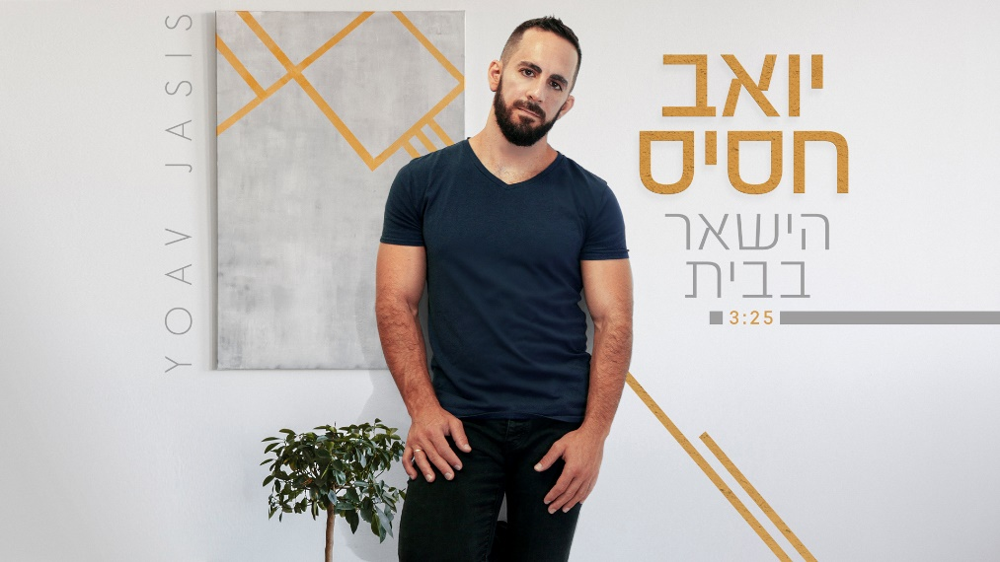

Yoav Jasis – “Stay Home”

He started his musical career with unique A-capella videos of popular Israeli songs. With the demand of his growing audience throughout the social networks – he published his original a-capella song Dabri in 2016.
His first album, Banali – was published in 2017 after a successful crowd-funding project. Since then, Yoav is working on a new album and released several new songs.
It is a concept album about the challenges of being a sensitive-masculine man, The need to ‘overcome and conquer’ at the expence of disengagement from emotions and how Yoav is dealing with it in his life.

At age 35 Yoav is married, a devoted father for two infants and a teacher.

For more info, contact: booliproductions@gmail.com

